***Harsh Patel***

***19528ph CS 535***

***Q-11)***

***A-11)***

*1) Data Confidentiality*

*2) Authentication*

*3) Data integrity*

*4) Non repudiation*

**Q-15)**

**A-15)**

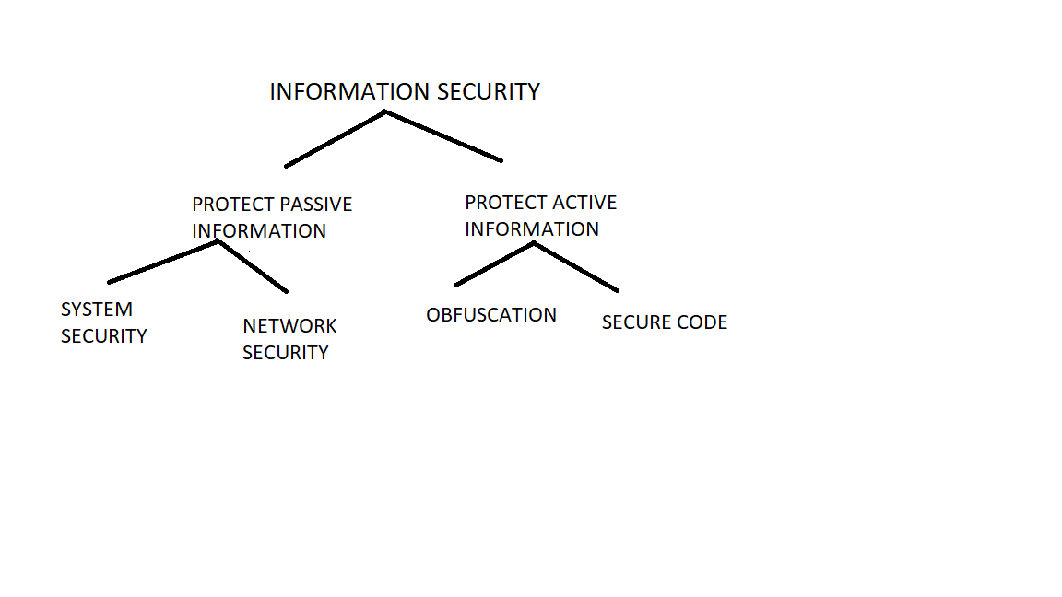

***Q-16)***

***A-16)***

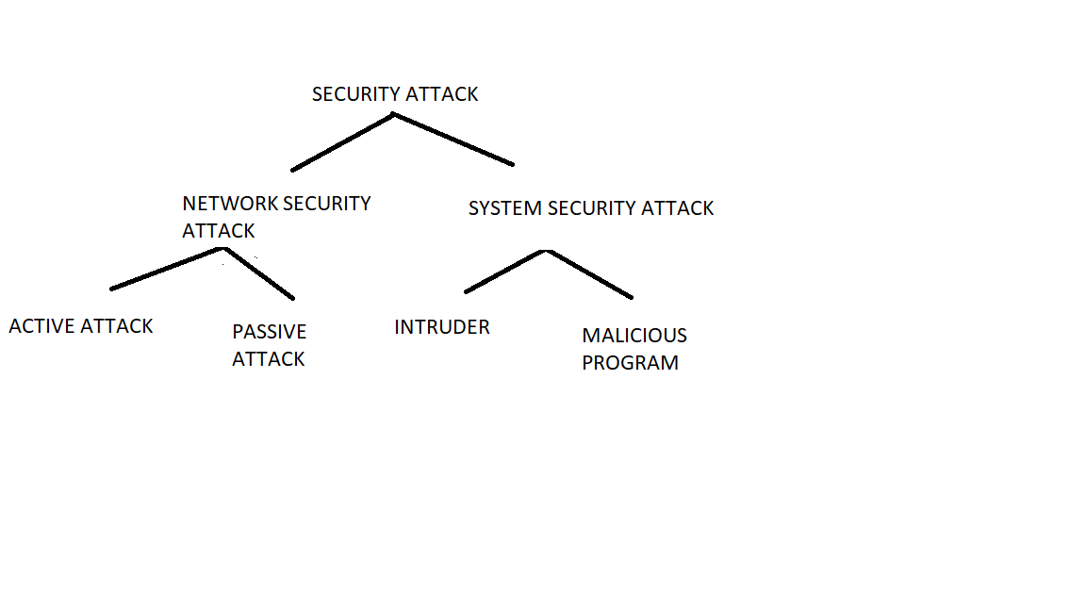

***Q-20)***

***A-20)***

*1) NSA*

*2) Security mechanism, Security service, Security Attacks*

*3) network security Attack and System Security Attack*

*4) Public Key*

*5) Diffi Whit*

*6) Integrity*

*7) Message digest*

*8) Digital certificate*